**SmartOven App**

**Design doc**



Contents

Introduction 2

**Scope** 2

**Terminology** 2

Software design description 3

**Software Design** 3

**Software architecture** 3

**User Interface** 4

**Data handling** 8

**Integration with other systems** 8

Tests and Monitor 8

**Tests** 8

**Logs** 8

**Alerts** 8

**A/B Testing** 8

Design doc

# **Introduction**

## **Scope**

Outdoor oven IoT software.

Responsive web application to control an outdoor oven/smoker. The software connects the client to the oven. The oven is in prototype phase, including the hardware development.

**Overview**

**?**

## **Terminology**

Cooking/smoking environment:

Prob: temperature measuring device. There are two types: meat prob and environment prob.

Blower: device for temperature control.

Spray nozzle: device used to convert liquid into a spray pattern. For this appliance it is meant to spray marinade over the meat.

Software:

Beans: Smallest component of the program, defines primary arguments to every entity.

Repository: interface for data base queries.

Service: logic classes, implement repositories and expands beans.

Controller: REST API's, client side-server communication.

# Software design description

The client will be able to create an account, use a cooking/smoking pre-programed process and create his own process (recipe) by entering data such as final meat internal temperature (R, MW, WD), oven temperature, cooking timer and marinade spray intervals.

Through the app the user will be able to start the cooking process, receive reminders and updates about the cooking stage and stop/turn off the oven if desired.

Future improvements: the ability to share recipes by creating a community of clients.

## **Software Design**

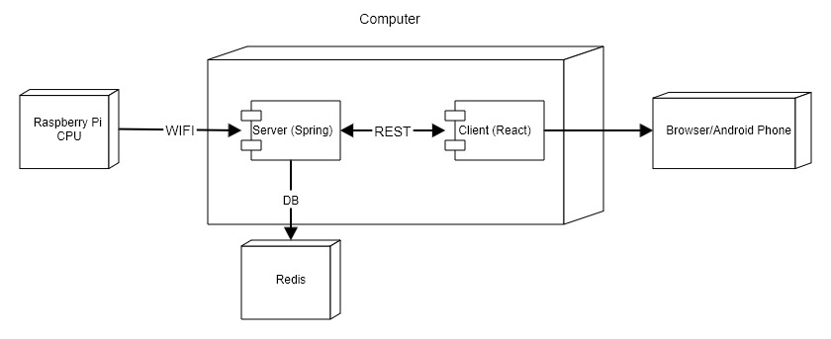

## **Software architecture**

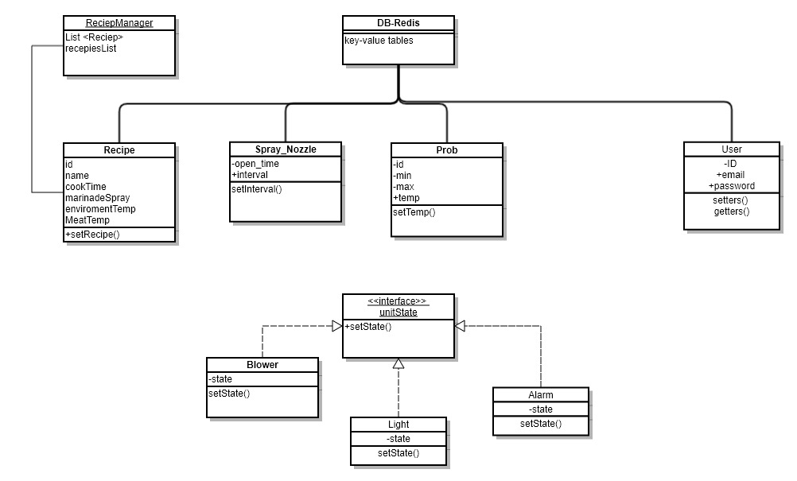

## **User Interface**

Overview

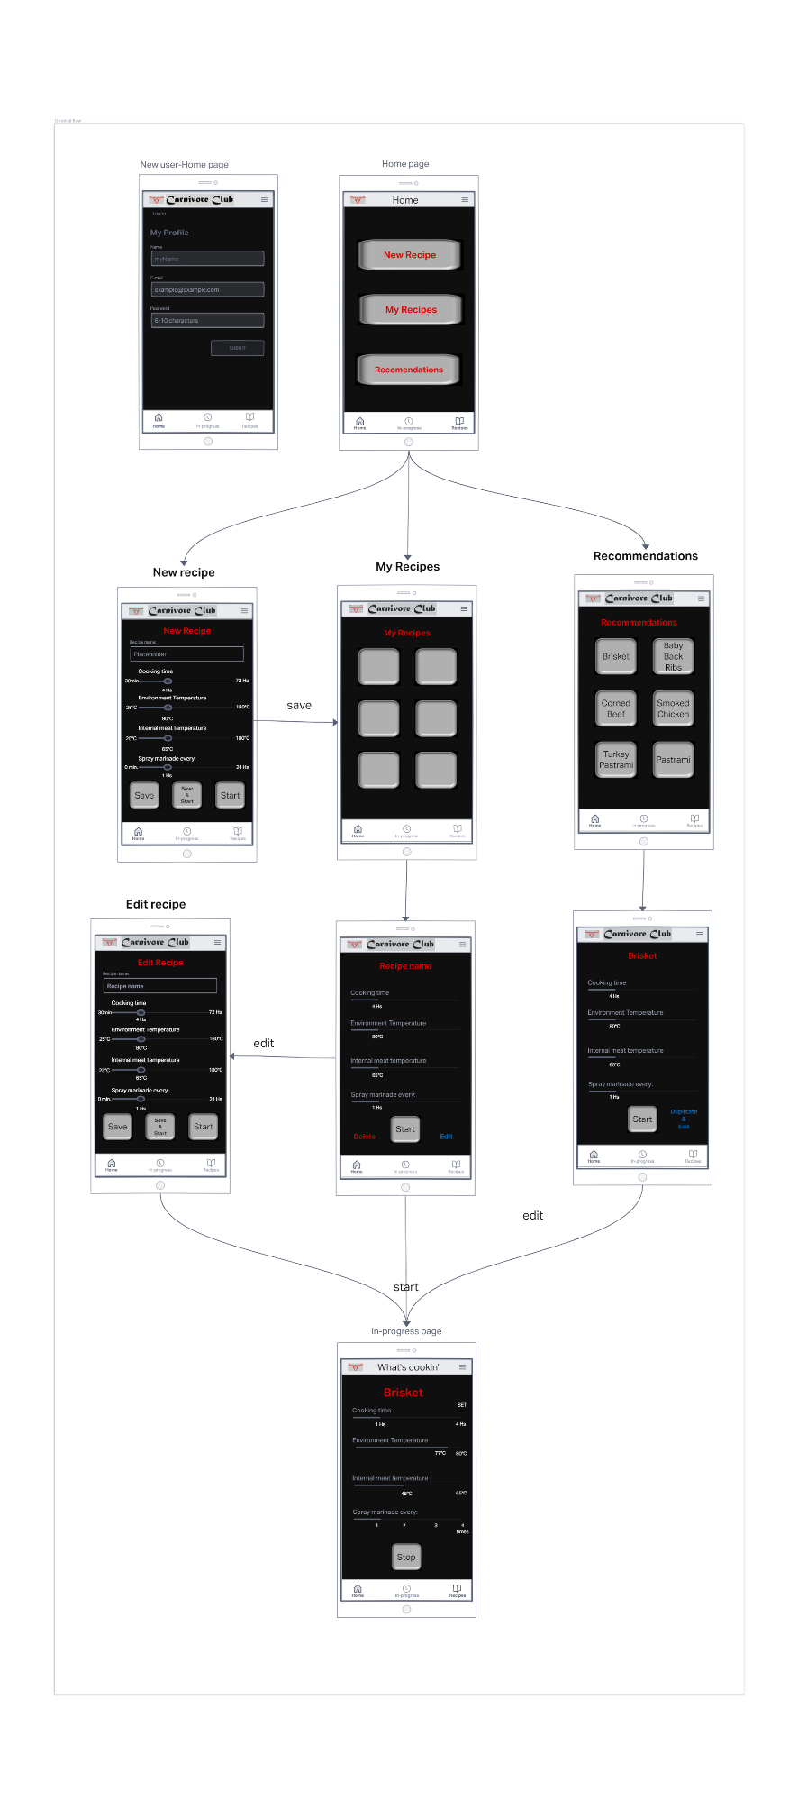

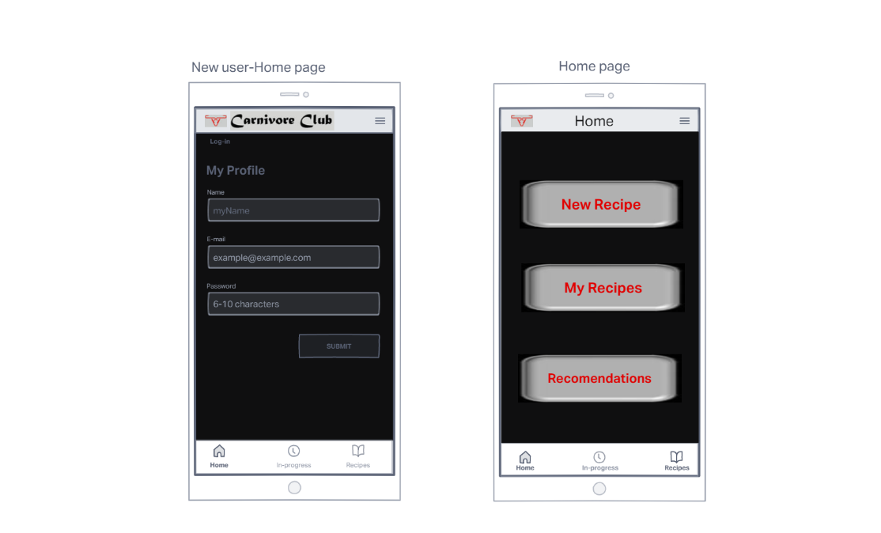 Home page

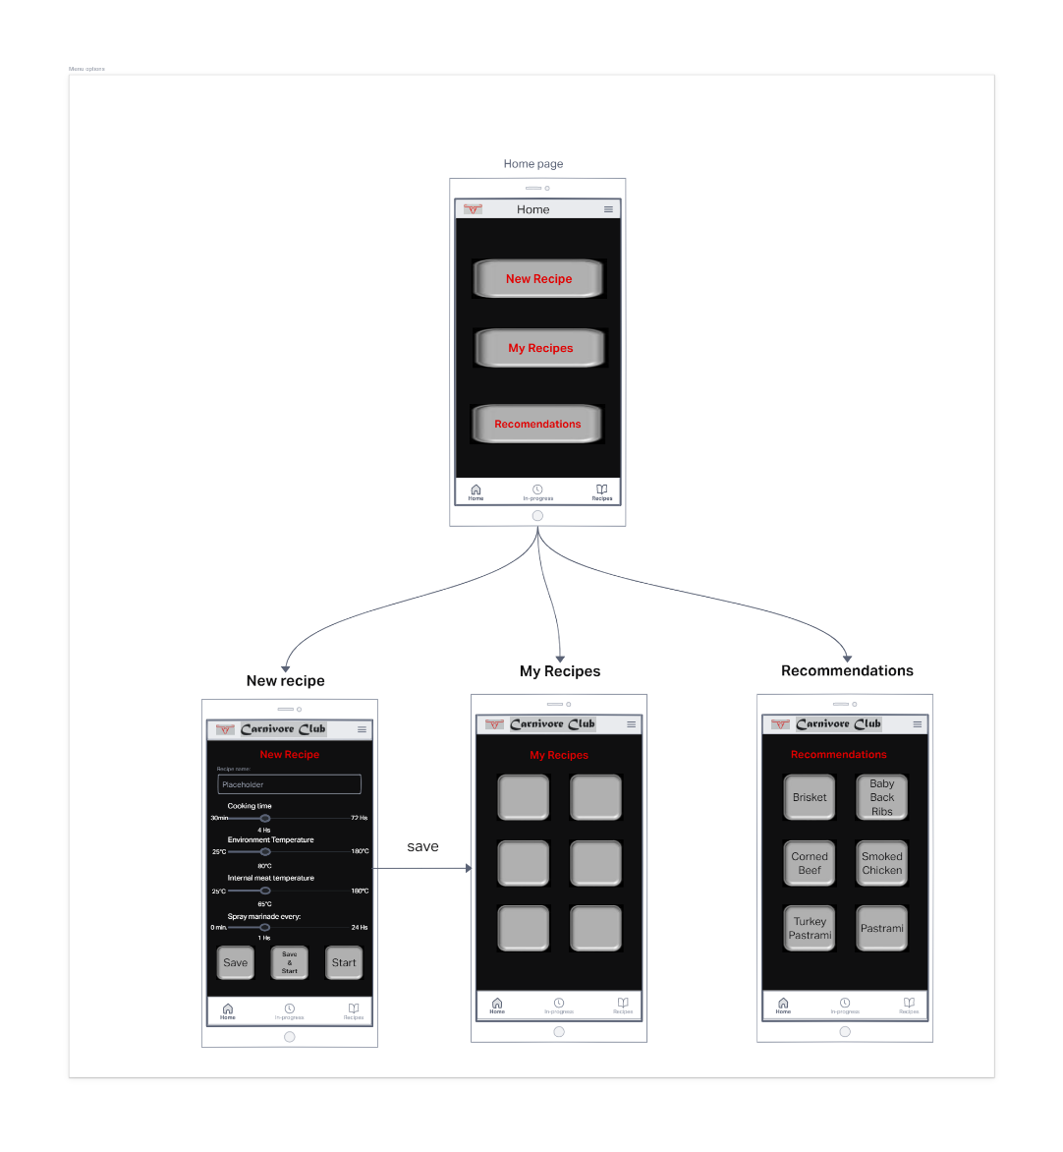

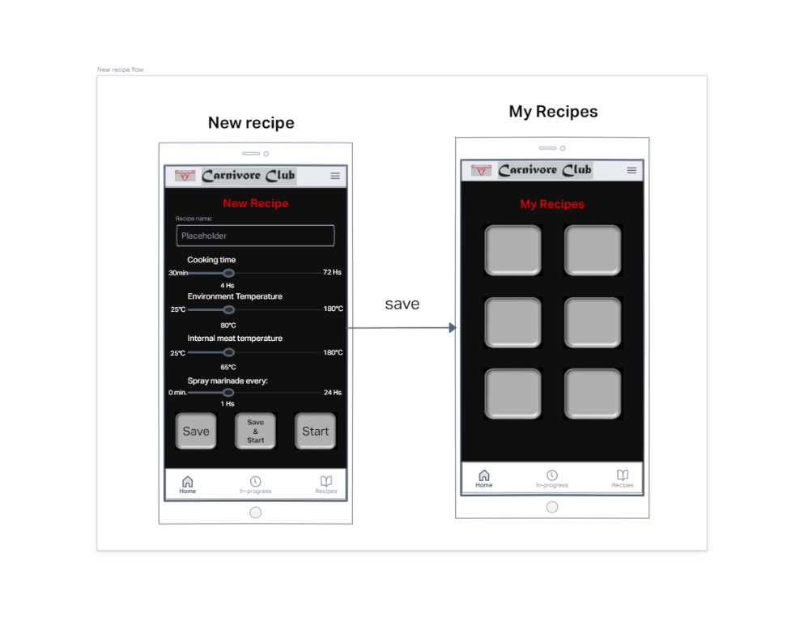New recipe screen flow

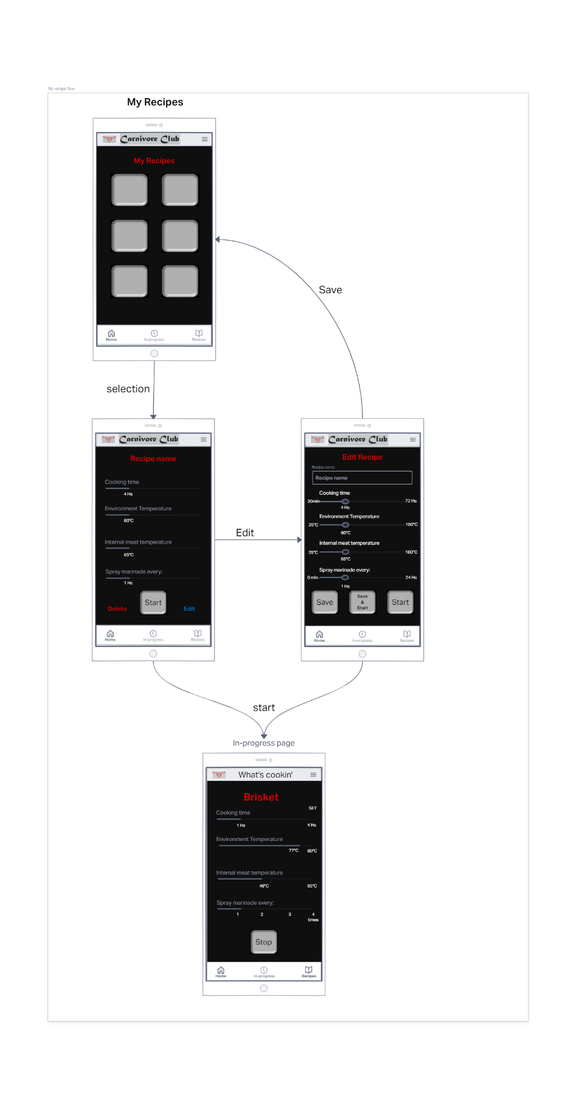

Recommendations screen flow

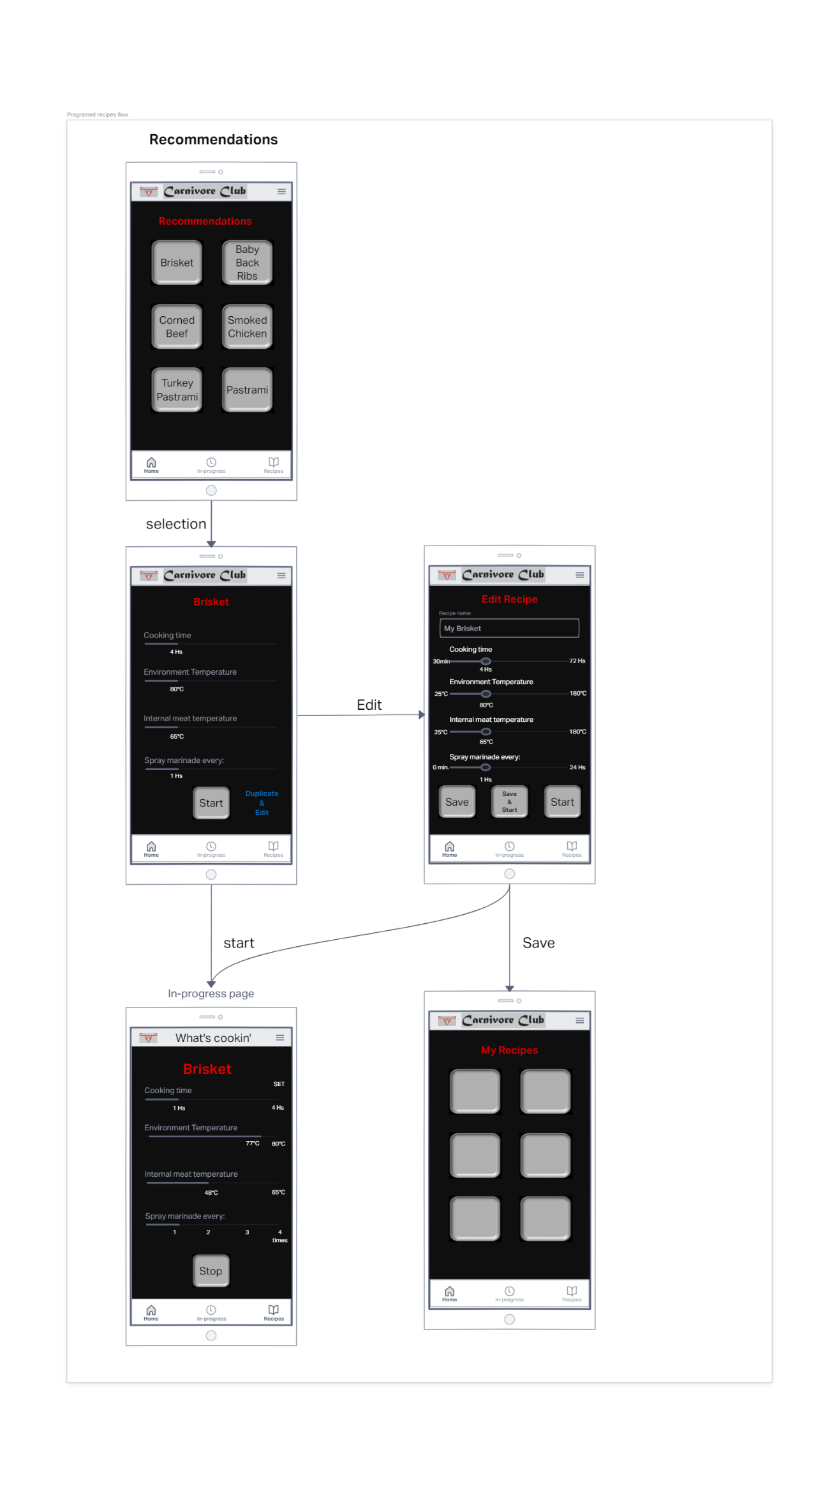

## **Data handling**

The data base is a Redis structured system to store user details, components values and recipe configuration.

User details: email and password.

Components values: name and values (array of max, min and current).

Recipe configuration: name and values (array of cooking time, environmental temp, internal meat temperature, spray interval)

## **Integration with other systems**

Hardware to backend:

Backend to front end through HTTP

Frontend to DB direct access via Redis.

# Tests and Monitor

## **Tests**

## **Logs**

## **Alerts**

## **A/B Testing**